OCR GCE A

COMPUTER SCIENCE PROJECT

H446-03

Name - <INSERT CANDIDATE NAME>

Candidate Number - <INSERT CANDIDATE NUMBER>

<INSERT SCHOOL NAME > - <INSERT CENTRE NUMBER>

Title of Project - Davacis

H446-03 – Project CONTENTS

Table of Contents

A. Analysis 3

B. Design 3

Systems diagram 3

C. Developing the coded solution (“The development story”) 3

D. Evaluation 3

Project Appendixes 4

# A. Analysis

**Problem Identification:**

The problem that I wish to solve is the gap of a magic-centric 1st person computer roleplaying game. I have seen many top-down CRPGs however, I have never seen a quality 3rd or 1st person one.

My project aims to fill this gap by being similar to the classic idea of an RPG, such as the ideas presented by Outward but with more modern features.

Several computational methods can be employed to solve the aforementioned problem.

Abstraction:

Decomposition:

**Stakeholders:**

A survey was conducted with the target audience, the results somewhat changed the focus of the game but many of the core element were supported by this.

The primary platform has not changed from the expected. It Is still windows, however there is interest in an Xbox and Playstation release. These would not be feasible during the time window of this project and would be considered post-release as maintaining 3 separate project would require a lot of time.

A factor I didn’t consider is support for gamepad input. This most likely stems from the support of a console release, but gamepad support should be considered.

An open-world game is clearly the best choice here as it was a landslide victory. The game was originally planned to be this as well.

Future beat Medieval by a moderate margin here, however I think that I should attempt to cater to both sides. As such, I believe that a mix of the two should be done. This could be done via having a Medieval setting with futuristic elements stemming from the magic elements.

The same is true for this question, except the margin slimmer. I believe that all of these should be offered as a choice at the start of the game, as It would not be all that hard to implement and would ensure that all players are happy. “Low” or “Moderate” would most likely be recommended, while the others are for the extremes of the player base.

These questions surprised me somewhat. I expected more of an even mix.

I originally planned to focus heavily on pure mages as that would be my preference. However, the data clearly demonstrates a desire for close range and melee fighting. As the game at its core is an RPG I should attempt to cater to all playstyles should time permit, but I will focus on magic that can be used with, or to support physical attacks first.

This further echoes the message above of desiring close-range engagements.

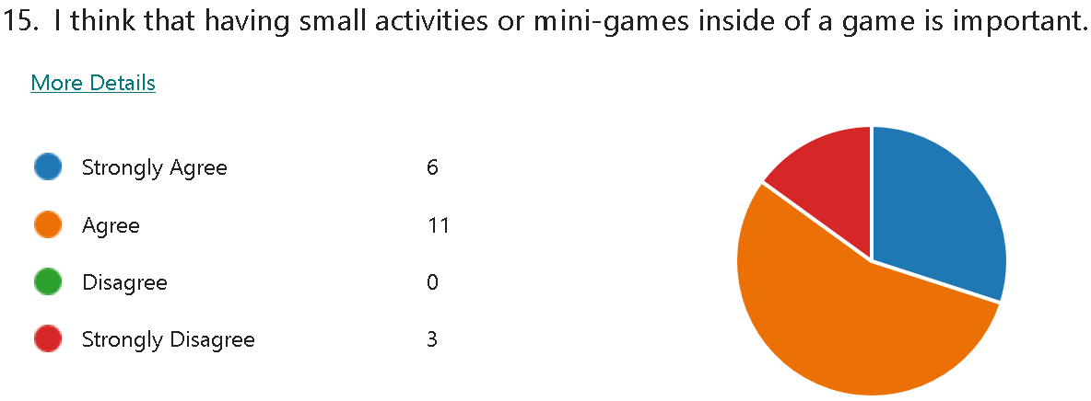

This question shows clearly that players would enjoy having some side-content that differs from the main gameplay loop. This is of course secondary to the main content but is worth reserving time for in my development plan.

Evidently, new game+ elements should be an option. These should be optional so that players aren’t forced to use them if they don’t want to however.

A majority agreed that magic should be explored outside of combat. This could be both for skills but also the plot. I think that this result reinforces the idea of a medieval setting with a dependence on magic for its technology.

This shows both than damage is the most important aspect for players, even if it is a hard to use spell due to its range or speed.

**Research:**

Skyrim:

Skyrim is a good example of how I’d like to divide magic. By splitting magic into schools, I can tailor the benefits given at each point of progression for the priorities of each school. I’d also like to follow the general progression set out in Skyrim as I like the per-skill progression and it allows the player to see what they like to prioritise.

Where I’d like to differ from Skyrim is I’d like each spell to be unique and impactful, mages should not be casting a ton of spells in a fight until higher levels. This will make each spell worthwhile to the player, and having quality over quantity is best, especially for this limited time project.

Outward:

Outward is a good example of a challenging RPG, I’d like to mirror it’s feeling of powerlessness at the start until the player is more powerful. On top of this, I would like equipment to have a large impact on the player, as in most games, equipment is solely stat buff or defence raiser. In this game I’d like to have it make magic behave differently and be found rarely. I’d like to differ from the magic system in Outward though, as it costs health to gain mana. It is also very reliant on synergies to have success and I believe that is somewhat out of scope and would not fit with the idea of the game.

Fictorum:

Fictorum is a good example of how customisable magic can both enhance a game and be it’s shortcoming.

In fictorum you have 3 slots on each spell to customise it, these often have a small trade off but it is less than it’s positive aspect. I’d like to implement a similar system of being able to edit spells, but I’d like to differ the execution.

Rather than finding runes, the player can tweak values to create permutations of each spell, similar to Arcane Odyssey.

In addition to changing the rune aspect, I’d like to implement more fleshed out physical combat.

**Essential Features:**

Camera System:

I believe that a 1st person camera would be most fitting to this project. I think this as it is the most immersive choice and allows for effects to be applied to the camera to emulate speed and such. It also means that a detailed character model is not needed.

Standard Movement System:

By keeping the basic movement as similar as possible to other games in the genre I can minimise the time needed to pick up the game. I can differentiate my project from others by including more advanced movement with magic.

Magic System:

By having the main difference between other games and mine be the magic system will indicate the main focus of the game.

I plan to have several elements and skills with different uses available to the player.

Health/Stamina:

Inventory and Equipment System:

**Limitations:**

**Solution Requirements:**

**Success Criteria:**

# B. Design

<See H446-03 Project Advice Booklet for help and guidance of what must go here.>

## Systems diagram

# C. Developing the coded solution (“The development story”)

<See H446-03 Project Advice Booklet for help and guidance of what must go here.>

# D. Evaluation

<See H446-03 Project Advice Booklet for help and guidance of what must go here.>

# Project Appendixes

Insert as many project appendixes as you need for your project.

These might include, but are not limited to:

* Complete Code Listing (ESSENTIAL)
* Interview Transcripts
* Meeting notes
* Observation notes or questionnaires

Spell ideas:

Meteor